Rotational Acceleration and Force
An object can move around in a circle with a constant speed yet still be accelerating because it’s direction is constantly changing. This acceleration, which is always directed in toward the center of the circle, is called centripetal acceleration. The magnitude of this acceleration is written as:

Centripetal acceleration =
(𝑙𝑖𝑛𝑒𝑎𝑟 𝑠𝑝𝑒𝑒𝑑)2

𝑟𝑎𝑑𝑖𝑢𝑠

or ac =
𝑣2

𝑟

I a mass is being accelerated toward the center of a circle, it must be acted upon by an unbalanced force that gives it this acceleration. This force, called the centripetal force, is always directed inward toward the center of the circle. The magnitude of the force is written as:
Centripetal force = (mass)x(centripetal acceleration)
𝑚 𝑣2
Or Fc = m ac =
𝑟
The units for centripetal acceleration and centripetal force are m/s² and N, respectively.
- Mr. Lindsay’s favorite ride at Lagoon is the rotor, which has a radius of 4.0 m. The ride takes 2.0 sec to make one full revolution.

- What is Mr. Lindsay’s linear speed on the rotor? (Hint: v =

𝑐𝑖𝑟𝑐𝑢𝑚𝑓𝑒𝑟𝑒𝑛𝑐𝑒
)
𝑝𝑒𝑟𝑖𝑜𝑑

- What is Mr. Lindsay’s centripetal acceleration on the rotor?

- A pilot of a 60,500 Kg jet plane, is told that he must remain in a holding pattern over the airport until it is his turn to land. The pilot flies his plane in a circle whose radius is 50.0 km once every 30.0 min, what centripetal force must the air exert against the wings to keep the plane moving in a circle?
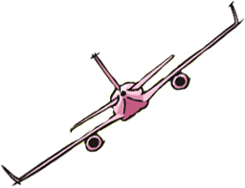

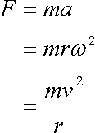
Note: Where ν = Linear velocity and ω = rotational velocity

- Mr. Lindsay is riding on a merry-go-round on an outer horse that sits at a distance of 8.0 m from the center of the ride. Mr. Lindsay’s wife, Becky, is on an inner horse located 6.0 m from the ride’s center. The merry-go-round turns around once every 40.0 sec.
- Explain which person is moving with the greater linear speed.

- Explain which person is moving with the greater rotational speed.

- What is the centripetal acceleration of Becky and her horse?

- What is the centripetal acceleration of Mr. Lindsay and his horse?

- Assuming that Mr. Lindsay is twice as massive as Becky, then which person requires more centripetal force to stay on the horse: (Explain by showing the math) (Hint: F = mω²r)

- A popular trick of many physics instructors are to swing a pail of water around in a vertical circle fast enough so that the water doesn’t spill out when the pail is upside down. If Mr. Lindsay’s arm is 0.60 m long, what is the minimum speed with which he can swing the pail so that the water doesn’t spill out at the top of the path and become a horizontal projectile?
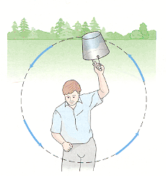
- To test their stamina, astronauts are subjected to many rigorous physical tests before they fly in space. One such test involves spinning the astronauts in a device called a centrifuge that subjects them to accelerations far greater than gravity. With what linear speed would an astronaut have to spin in order to experience an acceleration of 3 “g’s” at a radius of 10.0 m? (Note: 1 “g” = 10 m/s²)

- At the Fermilab-particle accelerator in Bativia, Illinois, protons are accelerated by electromagnets around a circular chamber of 1.00 km radius to speeds near the speed of light before colliding with a target to produce enormous amounts of energy. If a proton is traveling at 10% the speed of light, how much centripetal force is exerted by the electromagnets? (Hint: c = 3.00 x 10⁸ m/s & mp = 1.67 x 10⁻²⁷kg).

